EE 97 Fall 2016

Thurs. 1330

Lab #7: Time Constant, Oscillators, and Counter

Sidarth Shahri

Partner: Christian Lopez

Station 10

Submitted 17 November 2016

Lab #7: Time Constant, Oscillators, and Counter

Experiment 1

In this experiment, we examine the concepts of the time constants of capacitors. A capacitor can be simply described as an electrical component that stores charge. A capacitor behaves like a tank of water with a hole at the bottom when dissipating charge. When a tank of water is full, the water will empty out of the hole at a quick rate because of the high pressure. Likewise, a capacitor drains charge faster when it is close to fully charged. A capacitor behaves similarly when charging, filling faster when empty and more slowly when fully charged. A graph is shown below.

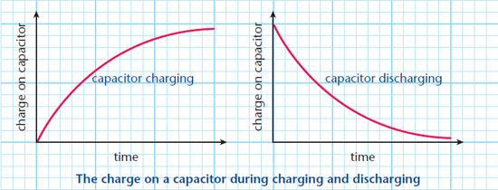

A capacitor will charge/drain logarithmically with respect to time. Therefore, a time constant can be used to describe how fast a capacitor will charge/drain. The time constant can be determined in a simple circuit involving a power source, a resistor, and a capacitor. In this case, the time constant will be τ = RC. In this experiment, the time constant is the time it takes for the capacitor to charge/discharge to 63% of its original value.

Measurements were taken in ENG 249 Station 10 on Thursday, November 3, 2016 using:

* Agilent Digital Multimeter 34405A (S/N: TW48090264)
* Tektronix DPO 3012 Oscilloscope (S/N: C010914)
* Agilent Function Generator 33220A (S/N: MY44042788)
* HP 33631A Triple Output
* Capacitance Meter – 830 Auto-ranging Meter (BK Precision) (S/N: 07299070052)

Resistor Measurement

10kΩ -> Actual: 9.7975kΩ

Capacitor Measurement

1µF -> Actual: 0.94µF

Schematic is shown below for how the circuit was wired up.

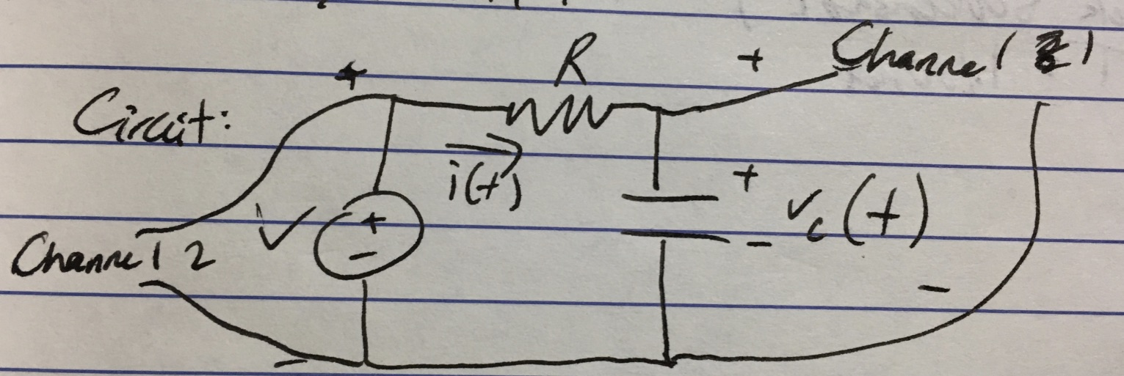

The oscilloscope trace of the charging cycle of the capacitor is shown below. This is for capacitor 1.

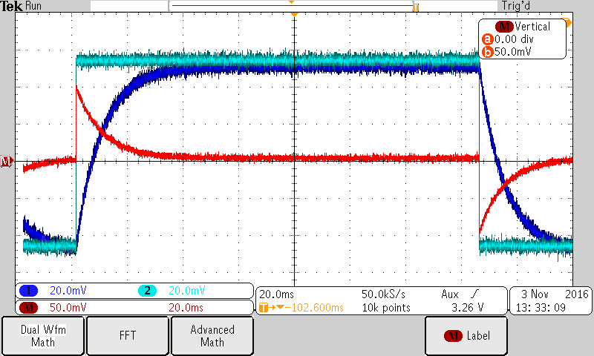

Channel 1 is wired across the voltage source while channel 2 is wired across the capacitor.

Capacitor 2’s screenshot is below.

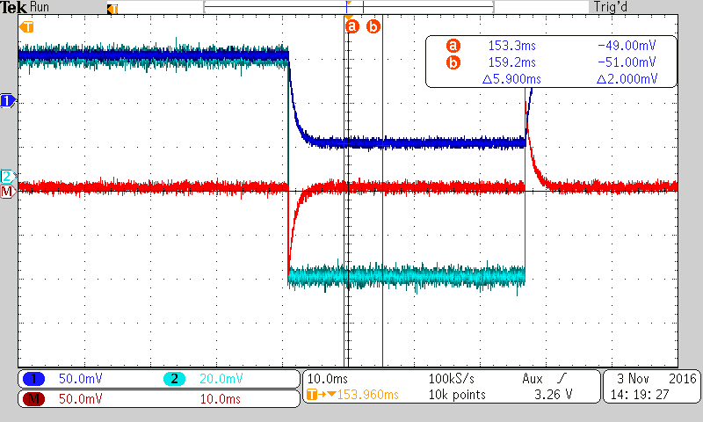

The time constant for this circuit’s capacitor was calculated and measured using the oscilloscope. The time constant can be defined as the product of the resistance and capacitance in the circuit or the time it takes for the capacitor to charge to 67% of its maximum capacity.

|  |  |  |  |  |  |
| --- | --- | --- | --- | --- | --- |
|  | Actual Capacitance [µF] | Calculated Time Constant (τ = RC) [s] | Frequency for Function Generator (1/RC) [Hz] | Measured Time Constant (τ = 67% of capacity) [s] | %Δ |
| Capacitor 1 - µF | 0.94µF | 0.00905 | 5.527329 | 0.0118 | 30.39% |
| Capacitor 2 – 100nF | 987nF | 0.000967 | 51.7055 | 0.00110 | 13.75% |

The current waveform is shown on the screenshots as the math function.

The time constant calculations match well with the measured time constant values. The measured values match well with the alternate measurements from the oscilloscope.

Experiment 2

An LM555 IC is capable of oscillating a voltage between two voltage values. A control circuit within the IC can sense the voltage of the circuit. In this experiment, a circuit was constructed to measure the oscillation of the output from an LM555 IC. The circuit is pictured below.

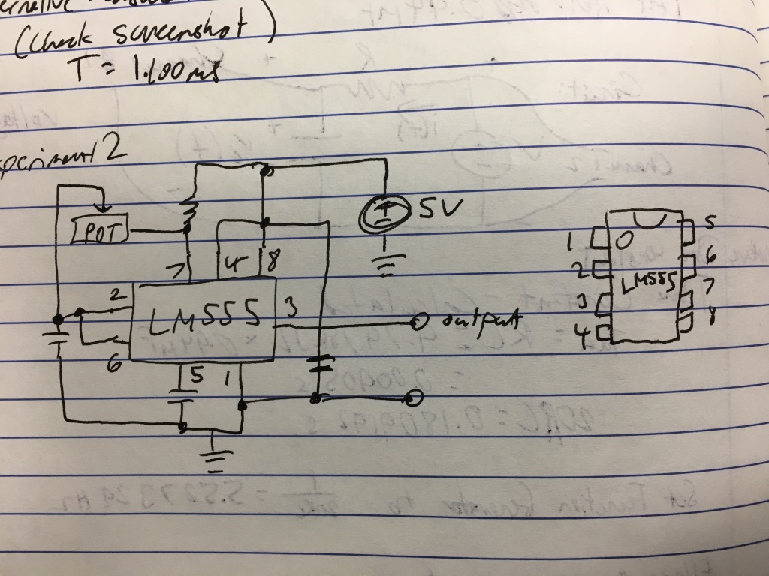

C1 = 0.1µF

R1 = 1kΩ

Calculated R2: 8248.481Ω

Below is the waveform across C1

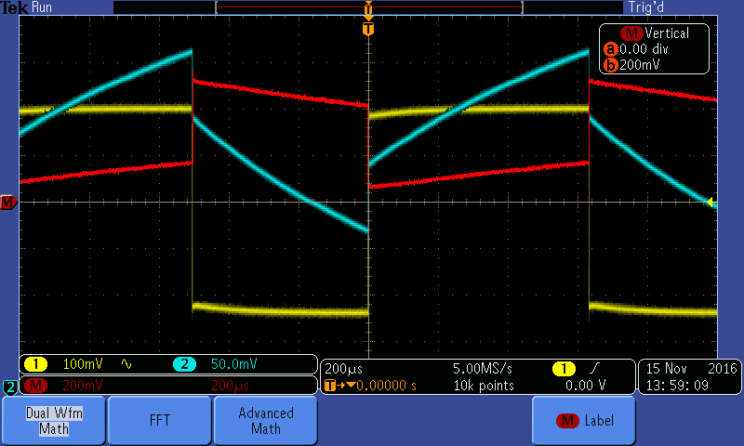

Below is the waveform for Pin-3’s ouput.

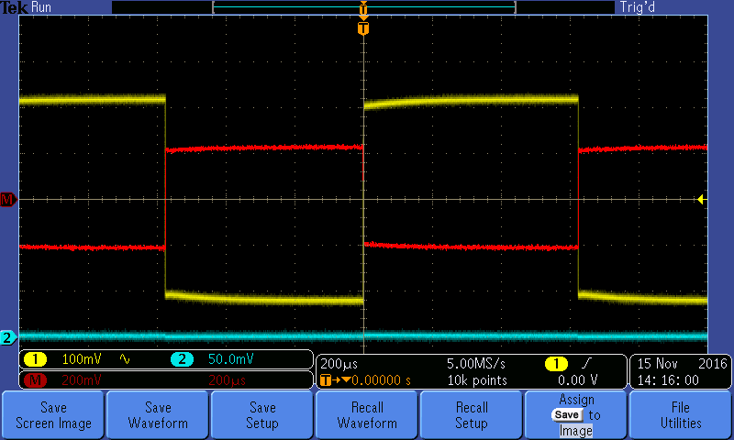

Pin 3 Output High = 220mV

Pin 3 Output Low = -220 mV

Frequency from scope: 823.8Hz

Frequency from DMM: 816.6Hz

%Δ = 13.5%

This lab demonstrated the time constant of capacitors while also showcasing their use cases. In the case of an oscillator chip, the LM555, a capacitor helps to filter out unwanted noise in the input and output. In the case of creating a counter and decoder, a capacitor offers similar benefits. The time constant of a capacitor can be easily determined using an oscilloscope.